HOUSEKEEPING AND HEALTH AND SAFETY MANUAL
CONFERENCES AND EVENTS
Central Teaching Hub
Address:  Central Teaching Hub  University of Liverpool  Liverpool  L69 7BX  Building Manager:  0151 795 9735 /  07970 247267 | Introduction
 | This section of your Event Sheet provides you with general housekeeping information and health and safety details whilst you and your delegates are on campus.
 | The Venue
The Central Teaching Hub consists of a mixture of lecture theatres, foyer space and laboratories. Organisers are requested to use only the space stated on their Event Sheet as confirmed by the Conference Office. Organisers or delegates are NOT permitted to enter unauthorised areas.

Organisers or delegates are NOT permitted to enter a laboratory unless authorised to do so.

The Building Manager’s office is located on the ground floor, straight ahead from the main entrance.

 | Toilets
 | Toilets are located on the ground floor of the Central Teaching Hub and Lab Building.
 | Accessibility Details
 | Further details regarding accessibility can be found at https://www.disabledgo.com/access-guide/university-of-liverpool/central-teaching-hub-2.
 | Fire Regulations
In the event of you finding a fire warn others in the vicinity and leave the building by the nearest emergency exit. DO NOT enter other rooms or collect your belongings from lockers on your way out.

If it is safe to do so, please sound one of the alarms located at the emergency exits as you leave the building. If it is not safe to do so, contact the security via a mobile telephone (0151 794 2222) or from the nearest safe building (2222).

Go to the fire evacuation point – Tree Lined Avenue and stand on the Chadwick side listen for announcements made by the building manager/senior fire warden/CTL staff identified by high visibility jackets. YOU MUST contact them IMMEDIATELY at the fire evacuation point if you have any details of the fire.

 | Test Fire Alarms
The fire alarms are connected to the lecture block. They are usually tested on a Wednesday at 2.30pm. There will be 2 alarm tests, one for CTL and one for lecture block and should last no more than 30 secs per alarm.

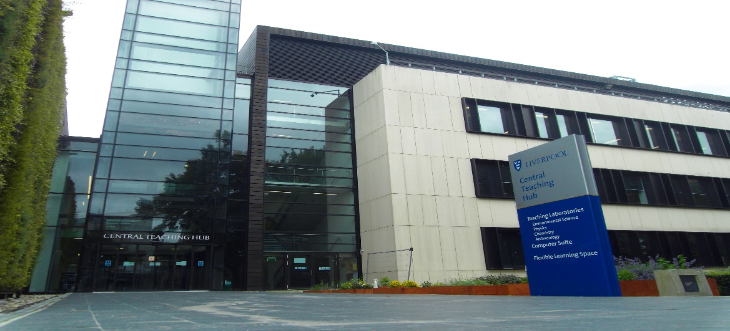

Health and Safety Regulations and Responsibilities
When conferences and events take place, it is the responsibility of the organiser and conference co-ordinator to ensure appropriate measures and arrangements are in place for the conference and event to run safely. In practice, duties will be delegated to those who are coordinating and participating in the event and they will have a part to play in ensuring that the premises are fit for purpose and that all equipment used is safe and free from defects.

The key issues to consider are listed below:-

Access and egress
Conferences and events normally mean a significant number of people visiting the University buildings, so ensuring that good access/egress is provided and maintained throughout the day is vital.

Stairwells, corridors and emergency escape routes should be kept clear of obstructions and combustible materials. In particular, stairwells and other spaces used for escape purposes should not be blocked with additional chairs, tables, display boards, waste bins and demonstration equipment.

Although wedging open doors may seem to create an open and inviting environment, fire doors must not be wedged or propped open. If fire doors have to be open to assist in directing people to the right areas, then individuals will have to be posted at each door and physically hold the door open. A combination of clear signage on doors and support staff in the area should eliminate the need to hold fire doors open.

NB – if fire doors need to be held open for operational reasons then magnetic or noise activated détentes can be fitted as a permanent solution. The Safety Adviser should be contacted in the first instance if you require this.

Room capacities
As organiser you will be responsible for confirming room capacities and layout of rooms with the conference co-ordinator 4 weeks prior to the event date. If you require any additional seating in any of the rooms then this will need to be confirmed with the co-ordinator.

There is often the temptation to add additional chairs in rooms where presentations are being given. All rooms will have a maximum capacity to ensure they meet fire safety regulations. If the room has fixed seating then this should be taken as the maximum number of people allowed in the space. In rooms with moveable seating, the organiser is to discuss additional seating with conference co-ordinator.

Controlled areas
Certain buildings may have hazardous or restricted areas that visitors should not enter and these should be clearly marked and controlled. Areas such as laboratories and workshops should be clearly signed, locked or occupied to prevent unauthorised entry. Plant and lift rooms and doors leading onto roof areas should also be locked – if you find any that are not, contact the Building Manager.

Slips, trips and falls
Slips, trips and falls are one of the main reasons why accidents occur on University premises. Simple precautions to take on conferences and events to reduce these types of accidents include:
- Ensuring the feet of demonstration boards do not protrude out into walkways and are always obvious to people walking past them (either place the boards well away from walkways or highlight the feet with black and yellow hatched tape).
- Ensuring cables from electrical equipment are routed in safe positions or, if this is not possible and they have to be placed across walkways, then suitable covers are placed over them.

Experiments and demonstrations during the conference
If experiments or demonstrations are planned, specific risk assessments may need to be prepared. The Conference Office will need to be informed of these 4 weeks prior to the event, so specific risk assessments can be completed.

Disability arrangements
If events associated with conferences and events are only held on the ground floor of buildings then access and egress arrangements will be suitable for all visitors. However, if events are to be held on floors above ground level (and means for accessing the floors are available – e.g. lifts) then suitable arrangements must be in place for the evacuation of disabled visitors. Most lifts in buildings cannot be used in the event of a fire so alterative arrangements need to be in place. This could include the use of evac chairs with a trained team of helpers. Before the event takes place, the organiser should discuss with the conference co-ordinator whether activities should be restricted to easily accessible areas or whether more needs to be done to ensure disabled visitors can be assisted out of the building should an emergency situation arise.

First aid
In most cases, current first aid arrangements will be adequate for the conferences and events although it is worth checking that designated organiser staff are available who know where the first aid box(es) are kept, can deal with basic first aid issues and can contact the emergency services should the need arise.
The Building Manager should be contacted in the first instance or contact Campus Support on 0151 794 2222 in case of an emergency.

Conferences and events – external events
In some cases conferences and events involve the use of outdoor spaces, e.g. University Square and Abercromby Square. Organisers should discuss this in advance with the conference co-ordinator to ensure safety measures are known.

Responding to unplanned events
Those in charge of organising the conferences and events should consider what could go wrong during the event and put in place appropriate measures to deal with incidents quickly and to prevent escalation. Examples include the fire alarm sounding, spillages and accidents and injuries.

Accidents and incidents
All accidents MUST be reported to the building manager IMMEDIATELY. You may need to provide specific details, especially if an injury has been sustained.

